**Revista de Informatica Te´ orica e Aplicada - RITA - ISSN 2175-2745´**

**Vol. 26, Num. 1 (2019) 26-35**

**RESEARCH ARTICLE**

**An Analysis of a Real Mobility Trace Based on Standard Mobility Metrics**

**Uma Analise de um Trac¸o Real de Mobilidade Baseada em M´ etricas Padr´ oes de˜ Mobilidade**

Marco Aurelio Spohn´ 1*, Matheus Henrique Trichez1

|  |
| --- |
| **Abstract:** Better understanding mobility, being it from pedestrians or any other moving object, is practical and insightful. Practical due to its applications to the fundamentals of communication, with special attention to wireless communication. Insightful because it might pinpoint the pros and cons of how we are moving, or being moved, around. There are plenty of studies focused on mobility in mobile wireless networks, including the proposals of several synthetic mobility models. Getting real mobility traces is not an easy task, but there has been some efforts to provide traces to the public through repositories. Synthetic mobility models are usually analyzed through mobility metrics, which are designed to capture mobility subtleties. This work research on the applicability of some representative mobility metrics for real traces analysis. To achieve that goal, a case study is accomplished with a dataset of mobility traces of taxi cabs in the city of Rome/Italy. The results suggest that the mobility metrics under consideration are capable of capturing mobility properties which would otherwise require more sophisticated analytical approaches.  **Keywords:** Mobility analysis — mobility metrics — mobility traces  **Resumo:** Um melhor entendimento da mobilidade, seja esta de pedestres ou qualquer outro objeto movel,´ e´ util e enriquecedor.´ Util devido suas aplicac¸´ oes aos fundamentos da comunicac¸˜ ao, com especial atenc¸˜ ao˜ a` comunicac¸ao em redes m˜ oveis sem fio. Enriquecedor porque torna-se poss´ ´ıvel apontar vantagens e desvantagens de como nos movemos ou somos movimentados. Ha muitos estudos focados em mobilidade em redes´ moveis sem fio, incluindo-se entre eles propostas de v´ arios modelos sint´ eticos de mobilidade. Conseguir trac¸os´ reais de mobilidade nao˜ e uma tarefa f´ acil, mas tem-se visto um crescente esforc¸o em disponibilizar trac¸os´ via repositorios p´ ublicos. Modelos sint´ eticos de mobilidade s´ ao geralmente analisados atrav˜ es de m´ etricas´ de mobilidade, as quais sao desenvolvidas para capturar sutilezas da mobilidade. Este trabalho investiga a˜ aplicabilidade de algumas metricas de mobilidade representativas no processo de an´ alise de trac¸os reais. Para´ se alcanc¸ar esse objetivo, um estudo de caso e elaborado utilizando-se uma base de dados de trac¸os de´ mobilidade de taxis obtidos na cidade de Roma/It´ alia. Os resultados sugerem que as m´ etricas de mobilidade´ em questao s˜ ao capazes de capturar propriedades da mobilidade que de outra forma exigiriam abordagens de˜ analise mais sofisticadas.´  **Palavras-Chave:** Analise de mobilidade — m´ etricas de mobilidade — trac¸os de mobilidade´ |
| 1*Computer Science, Federal University of Fronteira Sul, Brazil*  \***Corresponding author**: marco.spohn@uffs.edu.br  **DOI:** https://doi.org/10.22456/2175-2745.84330 • **Received:** 28/06/2018 • **Accepted:** 03/01/2019  *CC BY-NC-ND 4.0 - This work is licensed under a Creative Commons Attribution-NonCommercial-NoDerivatives 4.0 International License.* |

# 1. INTRODUCTION

A better understanding of mobility is paramount for enhancing wireless communications. Users want to get connected to the network no matter where and when. However, current solutions are usually limited when addressing mobility issues. One way to keep improving on mobility awareness in wireless communications is through the analysis of mobility traces. Such approach consists on obtaining mobility metrics from real movement traces, and then identifying patterns that may be useful when configuring or designing communication protocols.

There are many possible mobility patterns, depending on who or what are the mobile entities (*e.g.*, pedestrians, cars, buses, airplanes). One important input for mobile network simulations regards to the movement of mobile entities, which could be fed into the simulator or computed in real time. However, due to the lack of real mobility traces, synthetic mobility models came first, making them the *de facto* standard in wireless network simulators when it comes to defining movement properties.

The first synthetic mobility models do not capture any realistic movement properties, forcing the design community to work on more realistic models. Mobility metrics were proposed to provide some analytical insight into models’ properties, and for capturing basic movement properties which are useful for identifying mobility patterns [1].

Gathering mobility traces is a crucial issue, because it usually relies on some volunteer entrepreneurship. That is, volunteers provide information about their locations for some period of time (days, weeks, or months), usually without any reward other than their contribution to science and technology. There is also privacy issues which must be dealt with in order to protect users’ anonymity.

Once mobility traces are available, one must plan on how to analyse such data. From the traces, one could possibly derive synthetic models which capture real movement properties [2, 3]. On its turn, more realistic models can enhance the simulation of mobile networks [4, 5].

There are some trace repositories [6, 7, 8] which have received increased attention from the research community. Among them, CRAWDAD (*Community Resource for Archiving Wireless Data At Dartmouth*) [7] is focused on wireless network traces, providing an archive for mobility traces obtained from the research community.

Even though mobility metrics are usually designed having in mind synthetic mobility models, the metrics could well be explored into real mobility traces. One important question that arises is regarding their effectiveness on pointing out mobility properties. This work tries to assess the applicability of some representative mobility metrics for a dataset of mobility traces of taxi cabs in the city of Rome/Italy [9].

The remaining of this paper is organized as follows. Section 2 presents the background and methodology employed along this work. Section 3 shows all the results and their analysis, while Section 4 presents the related work. Section 5 concludes this work.

# 2. Background and methodology

First of all, we present a brief survey on synthetic mobility models and the mobility metrics under consideration. Second, we comment on the data used for our analysis and the tools

employed for processing the data.

## 2.1 Mobility models

The first mobility models, targeted for Mobile Ad Hoc Networks (MANETs), were introduced in the late 1990’s, and are solely based on mathematical modeling. Their main representative is the Random Waypoint (RWP), which remains broadly used in simulation-based works. In the RWP model, a node randomly chooses a destination point, and a constant speed to move toward such destination. Once reaching the destination, the node may stand still for some time (*i.e.*, pause time), before eventually starting a new move. Among other early models, there are the Random Walk, Random Direction, RPGM [10], Gauss-Markov [11], and Manhattan [12].

Mobility models started to improve circa 2005, when real movement traces were employed for designing and validating the models. Some representative models are the model based on communities (CMM) [13], SLAW (Self-similar Least Action Walks) [14], and Smooth [15]. CMM is basicaly based on the theory of social networks, taking into account how people come together and move according to their social relations (*i.e.*, *social attractiveness*). SLAW is a complex model that leverages on several statistical features found in the evaluation of real human walks, such as pause time power-law distributions, inter-contact time, and trip length, as well as restriction on node’s mobility within confined areas, and fractal waypoints. Smooth was proposed as a simple alternative to generate realistic traces similar to SLAW, but using simpler input parameters. There are some surveys [16, 17, 18] covering the main mobility models.

## 2.2 Mobility metrics

Mobility metrics are analytical measures for capturing movement patterns. Some metrics are derived from the graph theory (*e.g.*, vertex degree, and link/path measurements), while others are velocity-based (*e.g.*, speed magnitude, angle) [12]. When the distance among nodes is a key factor, the metric is classified as distance-based (*e.g.*, the degree of node proximity) [19]. In case time is a prime factor, we have a time-based metric (*e.g.*, average link lifetime). Metrics addressing both the node location and the network area are labeled as spatial metrics.

Next, we briefly describe some mobility metrics which have been shown to be effective on analysing the most representative synthetic mobility models [20, 21, 22, 23, 19].

### 2.2.1 Speed-Angle Rate (SAR)

Let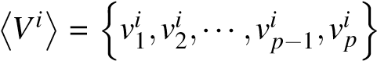 represent the sequence of the p-th speeds of node *i* during a period of time steps, *t* = 0 to *t* = *T*, where *vik* 1, and *p* ≥ 1.

Let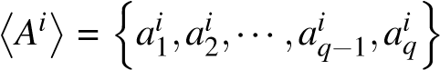 represent the sequence of *q* direction angles of node *i* during the same period of time, such that *aik* 1, and *q* ≥ 1.

Given that T is the the maximum number of speed/angle changes, the cardinality ofis always bounded

by *T* (*i.e.*, h*Vi*i, h*Ai*i ≤ *T*). Since h*Vi*i = *p* and h*Ai*i = *q*, the rate *qp* refers to the number of speed changes for each angle change, and it is referred to as the Speed-Angle Rate (SAR). As both *p* and *q* varies from 1 to T, it follows that .

**2.2.2 Angle Coefficient of Variation (ACV)** Due to the diversity of units for speed, angle, and time, velocitybased metrics should be independent of unit (*i.e.*, dimensionless). One of the measures used to characterize the variability of a variable that can be represented by different units of measure is the coefficient of variation (CV), which is defined as the ratio of the standard deviation to the mean. CV as a normalized measure of dispersion is free of scales (*i.e.*, dimensionless). Since the magnitude and angle of the speed are ratio variables, the CV can be used without restrictions.

Let *µa* denotes the average between all nodes’ angle of speed during *T*, and *σa* be the standard deviation of these values. The Angle Coefficient of Variation (ACV) is given by *σa/µa*.

### 2.2.3 Average Trip Length (ATL)

A trip (or flight) is defined as the movement between two consecutive waypoints. Let be the waypoints of node *i* during a period of time. The distance of the trip from *wk* to *wk*+1 is given as follows:

*ATL*(*wik,wik*+1)= *Dist*((*xwi k,yiwk*)*,*(*xwi k*+1*,yiwk*+1)) (1) where *xwi k* and *yiwk* are the x and y-coordinates of node *i* at the *kth* waypoint, and *Dist*(*wik,wik*+1) is the Euclidean distance between two consecutive waypoints.

**2.2.4 Degree of Link Changes (DLC)** The number of link changes (LC), for any pair of nodes *i* and *j*, is the number of times the link between them is effectively established [12]. Let *E*(*i, j,t*) be a boolean variable equal to 1 when there is a link between nodes *i, j*, and 0 otherwise. Additionally, let *E*(*i, j*) denote a boolean value that is equal to 1 if at least once there was a link between *i* and *j* during the network lifetime, and 0 otherwise. Based on that, LC is define as follows:

#### N−1 N T

1

*LC*(*i, j*)= *P i*∑=1 *j*=∑*i*+1*t*∑=1*C*(*i, j,t*) (2)

where P is the number of node pairs *i, j* such that E(*i*,*j*) = 1, and C(*i*,*j*,*t*) = 1 if E(*i*,*j*,*t* − 1) = 0 and E(*i*,*j*,*t*) = 1 or E(*i*,*j*,*t* −1) = 1 and E(*i*,*j*,*t*) = 0.

On its turn, the Degree of Link Changes (DLC) normalizes the LC metric, as follows:

*N N*

2

*DLC* = ∑∑ *LC*(*i, j*)*.* (3)

*N*(*N* −1) *i*=1 *j*=*i*+1

**2.2.5 Degree of Network Spatial Distribution (DNSD)** The degree of network spatial distribution at time *t* is defined as follows:

*DNSD*(*t*)= 1−log(*DEV*(*t*)+1)*/*log(*MAX* +1) (4)

where *MAX* = log(4(*N* −1)) is the maximum node dis-

tribution deviation, and *DEV*(*t*) is the sum of all elements in the horizontal and vertical distribution matrices (HDM and VDM, respectively) at time step *t*. The DNSD value will be the average of *DNSD*(*t*) over 0 *< t* ≤ *T*.

### 2.2.6 Degree of Spatial Accessibility (DSA)

Considering the same modeling employed for computing DNSD, the degree of spatial accessibility is given as the proportion of visited cells by the total number of cells. Note that a cell *c*(*i, j*) is said to be visited if at least one node was placed in the cell at some moment.

In geographic restricted mobility models, there are regions on the map where a node can never be. Consequently, the DSA will be lower in those models than in random models (*e.g.*, Random Waypoint), where a node may be anywhere. Thus, the benefits of this metric are twofold: a) to distinguish between geographic restricted and geographic unrestricted mobility models, and for somehow quantifying the user movement freedom level for a given scenario.

Let *x*(*i, j*) be an indicator random variable that informs whether a cell was visited by at least one user, which means that *x*(*i,t*)= 0 if *c*(*i, j*)= 0 or *x*(*i,t*)= 1 if *c*(*i, j*) *>* 0. Thus, the degree of spatial accessibility of a network at time *t* is defined as follows:

*N x*(*i, j*)

*DSA*(*t*)= (5)

*N*2

**2.2.7 Improved Degree of Temporal Dependence (IDTD)** The degree of temporal dependence indicates whether the movement is random or predictable (*i.e.*, temporal). For its representation, a scale from 0 to 1 is apropriate, where value 0 indicates a totally random movement, while value 1 suggests a totally temporal movement. In order to be properly captured, the metric should be computed only when a node velocity changes.

Let *Cos*(*i,t*) be the cosine of the angle between the velocities of node *i* at time steps *t* and *t* −1 (Equation 6), and *SR*(*i,t*) be the speed ratio of node *i* at time steps *t* and *t* −1 (Equation 7). Thus, the Improved Degree of Temporal Dependence for node *i* at time *t*, IDTD(i,t), is shown in Equation 8.

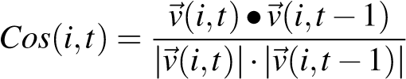 (6)

*SR*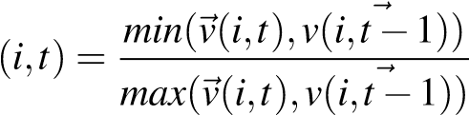 (7)

(

0, if *velocityHasNotChanged()*

*IDTD*(*i,t*)= (8)

*Cos*(*i,t*)×*SR*(*i,t*), otherwise

where the function *velocityHasNotChanged()* is true iff *~v*(*i,t*) =*~v*(*i,t* − 1) and *θ*(*i,t*) = *θ*(*i,t* − 1). Therefore, the average IDTD is computed as follows:

## 1 *N T*

*IDTD* = *Q i*∑=1*t*∑=1*IDTD*(*i,t*) (9)

where Q is the number of tuples (*i,t*) such that *IDTD*(*i,t*)6= 0*.*

**2.2.8 Degree of Node Proximity (DNP)** The Degree of Node Proximity (DNP) is a spatial mobility metric based on the distance between pairs of nodes. Let *N* be the number of mobile nodes, *T* the network simulation time, and *D*(*i, j,t*) the Euclidean distance between nodes *i, j* at time *t*. The transmission range (*R*) is employed as the distance unit for computing a relative distance between nodes [24]. Therefore, the average relative distance between nodes *i, j* from time 0 to *T*, *AD*(*i, j*), is defined according to equation 10.

*R*

*AD*(*i, j*)= (10)

*T*

Considering that the number of pairs of nodes in the network is *N*(*N* −1)*/*2, the average relative distance between all nodes from time 0 to *T* (*AD*) is computed as follows:

## 1 *N N*

*AD* = *N*(*N* −1)*/* ∑∑ *AD*(*i, j*) (11)

2 *i*=1 *j*=*i*+1

In order to normalize the values of *AD* into the range [-

1,+1], *AD* is divided by the maximum average distance, *MAD*, which is equal to the half of the maximum possible distance between two points in the scenario. *MAD* is also measured relative to *R*, being computed as follows:

*MAD*  (12) 2*R*

The ratio between *AD* and *MAD* gives a notion about the degree of mobility dependence. When the average distance among nodes keeps short, it is possible that nodes are moving along. Given that, DNP is defined in Equation 13.

*AD*

*DNP* = 1− (13)

*MAD*

### 2.3 Data and tools

Getting mobility traces from third parties is not a straightforward task. To address that, there has been a joint effort in the research community to make publicly available mobility traces through repositories [6, 7, 8]. Among them, CRAWDAD [7] is focused on mobile wireless networks, by keeping mobility traces ranging from pedestrians mobility to vehicular traces. In particular, our analysis is focused on a CRAWDAD’s dataset of mobility traces of taxi cabs in the city of Rome/Italy [9, 25]. The dataset presents the traces gathered from more than 300 taxis during 30 days, with the current locaction of each active taxi being recorded every six seconds. Figure 1 depicts the region of Rome under consideration, delimited by the geographical coordinates (41*.*7908*,* 12*.*3538) and (42*.*0062*,* 12*.*6216) (represented by the red and green markers, respectively).

For analysing the dataset, we have extended the Mobility Trace Analyzer (MTA) [26], which is by itself an extension of

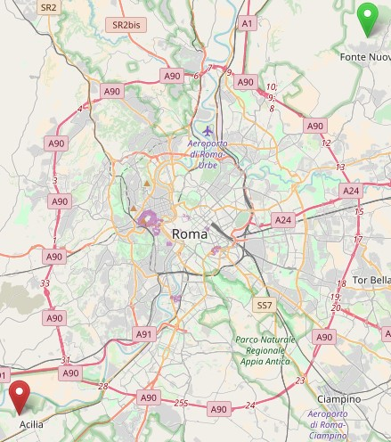

**Figure 1.** Region of Rome corresponding to the dataset

the IMPORTANT framework [27]. First of all, all the required mobility metrics were included in the MTA. Secondly, the dataset had to be converted to the format natively supported by the MTA (*i.e.*, ns2 [28] trace format). Such conversion was not straightforward, because there are some MTA input parameters (*e.g.*, the average pause time) which have to be computed properly beforehand; otherwise, metrics would not be duly computed or not computed at all.

For the purpose of reproducibility and repeatability, our dataset[1] and tools[2] are publicly available through an on-line repository.

# 3. Results and analysis

We have computed the selected mobility metrics for all dataset.

Results are depicted on Figures 2, 3, 4, and 6, with metric

ATL shown separately in Figure 5. As radio range (RR) is one important input parameter, we have defined it as 500 m for our first analysis. Even though it might be considered a large range when taking some usual technologies as reference (*e.g.*, WiFi), it leverages on the fact that wireless communication in our scenario has a renewable source of energy (*i.e.*, one can take as granted the fact that batteries are dinamically recharged).

|  |
| --- |
| **Figure 2.** First week results |

DNP values range from −1 to 1, meaning that nodes are farthest or closest to each other, respectively. The overall results show that most cabs are usually within range of other cabs.

When the Coefficient of Variation (CV) is lower than one

(*i.e.*, *CV <* 1), it indicates low-variance; meanwhile, *CV >* 1 points to high-variance. Particularly for the ACV metric, results suggest that the majority of cabs follow paths with similar directions (*i.e.*, there might be very similar rides, not necessarily by the same users/clients).

With very few exceptions, we notice some regularity in the average trip lenght (ATL) when comparing results for each individual week (Figure 5). The results suggest that there is some similar trips taking place during or around the same period of time along each day of the week. Considering that we do not have more details about the trips, it could well be that there is some sort of pattern for the type of usual trips users take during specific time throughout the day. That is, it does not unveil that there are some regular customers, but at least that there are some sort of common trajectories for most of the periods of each day of the week.

Even though DNP results indicate that most of the time there are many cabs within range of each other, DLC results add to that the fact that there might have high volatility on link duration. That is, as links get established frequently they also break very often, resulting in a high degree of link changes.

The DSA metric gives a measure of the user movement freedom level. When the movement is geographicaly restricted, as it is when moving along the streets in a city, the DSA metric is expected to present lower values. That is exactly what we see for our dataset, with DSA values mostly lower than 0*,*4. Likewise, the DNSD metric measures the node distribution along the network, with lower and upper bounds reflecting less or more spatial uniformity, respectively. DNSD results suggest a low uniformity, what is expected given the large area of the city taken under consideration. It is worthwhile to mention that, as cabs tend to go to overlapping regions in the city, there will be smaller regions with more cabs, hence reducing uniformity along the whole area.

The degree of temporal dependence tells us about whether the movement is random or predictable (*i.e.*, temporal). Results for the IDTD metric suggest that movement is not predictable for the overall scenario. Even though that might sound awkward, given that there is some particular patterns as pointed out before, one should look at the facts which may be leading to such results. We have to consider that there are many individual and independent rides comprising the overall data set. Even though each individual ride is somehow predictable (*i.e.*, any particular ride can be seen as a well defined itinerary), they are still independent, and as the IDTD results add up they end up reflecting such independence.

|  |
| --- |
| **Figure 3.** Second week results |

## 3.1 Extending the analysis to the context of mobility models

As mentioned before, dozens of mobility models have been proposed in order to mimic real mobility. From the simplest, with strictly artificial movements, to the more complex ones that take into account geographical constraints or group behavior among nodes. Amongst the most popular there are those included in the *Bonnmotion* [29] tool, broadly used by the research community in mobile ad hoc networks.

For the identification of the mobility model that best represents the traces under consideration, we have applied the model proposed by Cavalcanti and Spohn [30], which basicaly derives a Decision Tree (DT) for classifying traces based on mobility metrics. As previously mentioned, the dataset was split into 720 files corresponding to the 28 days in an hourly basis. After processing the 720 files, and applying the DT, three mobility models were identified to match the traces: CMM for 480 files, Column for 123 files, and RPGM for 117 files. Even though different models have been identified for the dataset, all the three identified models follow a realistic approach aimed at the simulation of *ad hoc* networks. The Column [31] model understands the scenario as a grid when computing the traces, with nodes moving strictly over the grid. For our scenario, we have taxis moving in a geographicaly constrained environment defined by the streets within sets of blocks. The Reference Point Group Mobility (RPGM) [32] employs a clustering policy for nodes, having groups of nodes moving along. In our case, the match is most likely due to the common destinations during the observed periods. CMM [33] was the model with more observed matches. It is based on the social network theory, by modeling the movement of nodes based on their social relations. Once again, it is possible that the results reflect not only the implications of common destinations or interests, but also any possible relations among the users moving to/from such destinations.

# 4. Related work

Hoque *et al.* [34] present an analysis of mobility patterns for taxi cabs in San Francisco/CA. Their work is focused on cabs’ characteristics such as: instantaneous velocity; spatiotemporal distribution; pick up and drop off frequency distribution; hot-spots identification; busy and vacant durations; connectivity among vehicles; and, clustering and network partitioning. The mobility metric *Average Degree of Connectivity* (ADoC) was introduced for characterizing the reachability of any random node in the network. Their results show that as the radio range increases, the ADoC increases faster for smaller number of hops (*i.e.*, more cabs are reachable within shorter paths).

Cunha *et al.* [35] analyzed two mobility datasets: the same one used in our work, and another one gathered in San Francisco/CA. When equipped with radios, the cabs can be

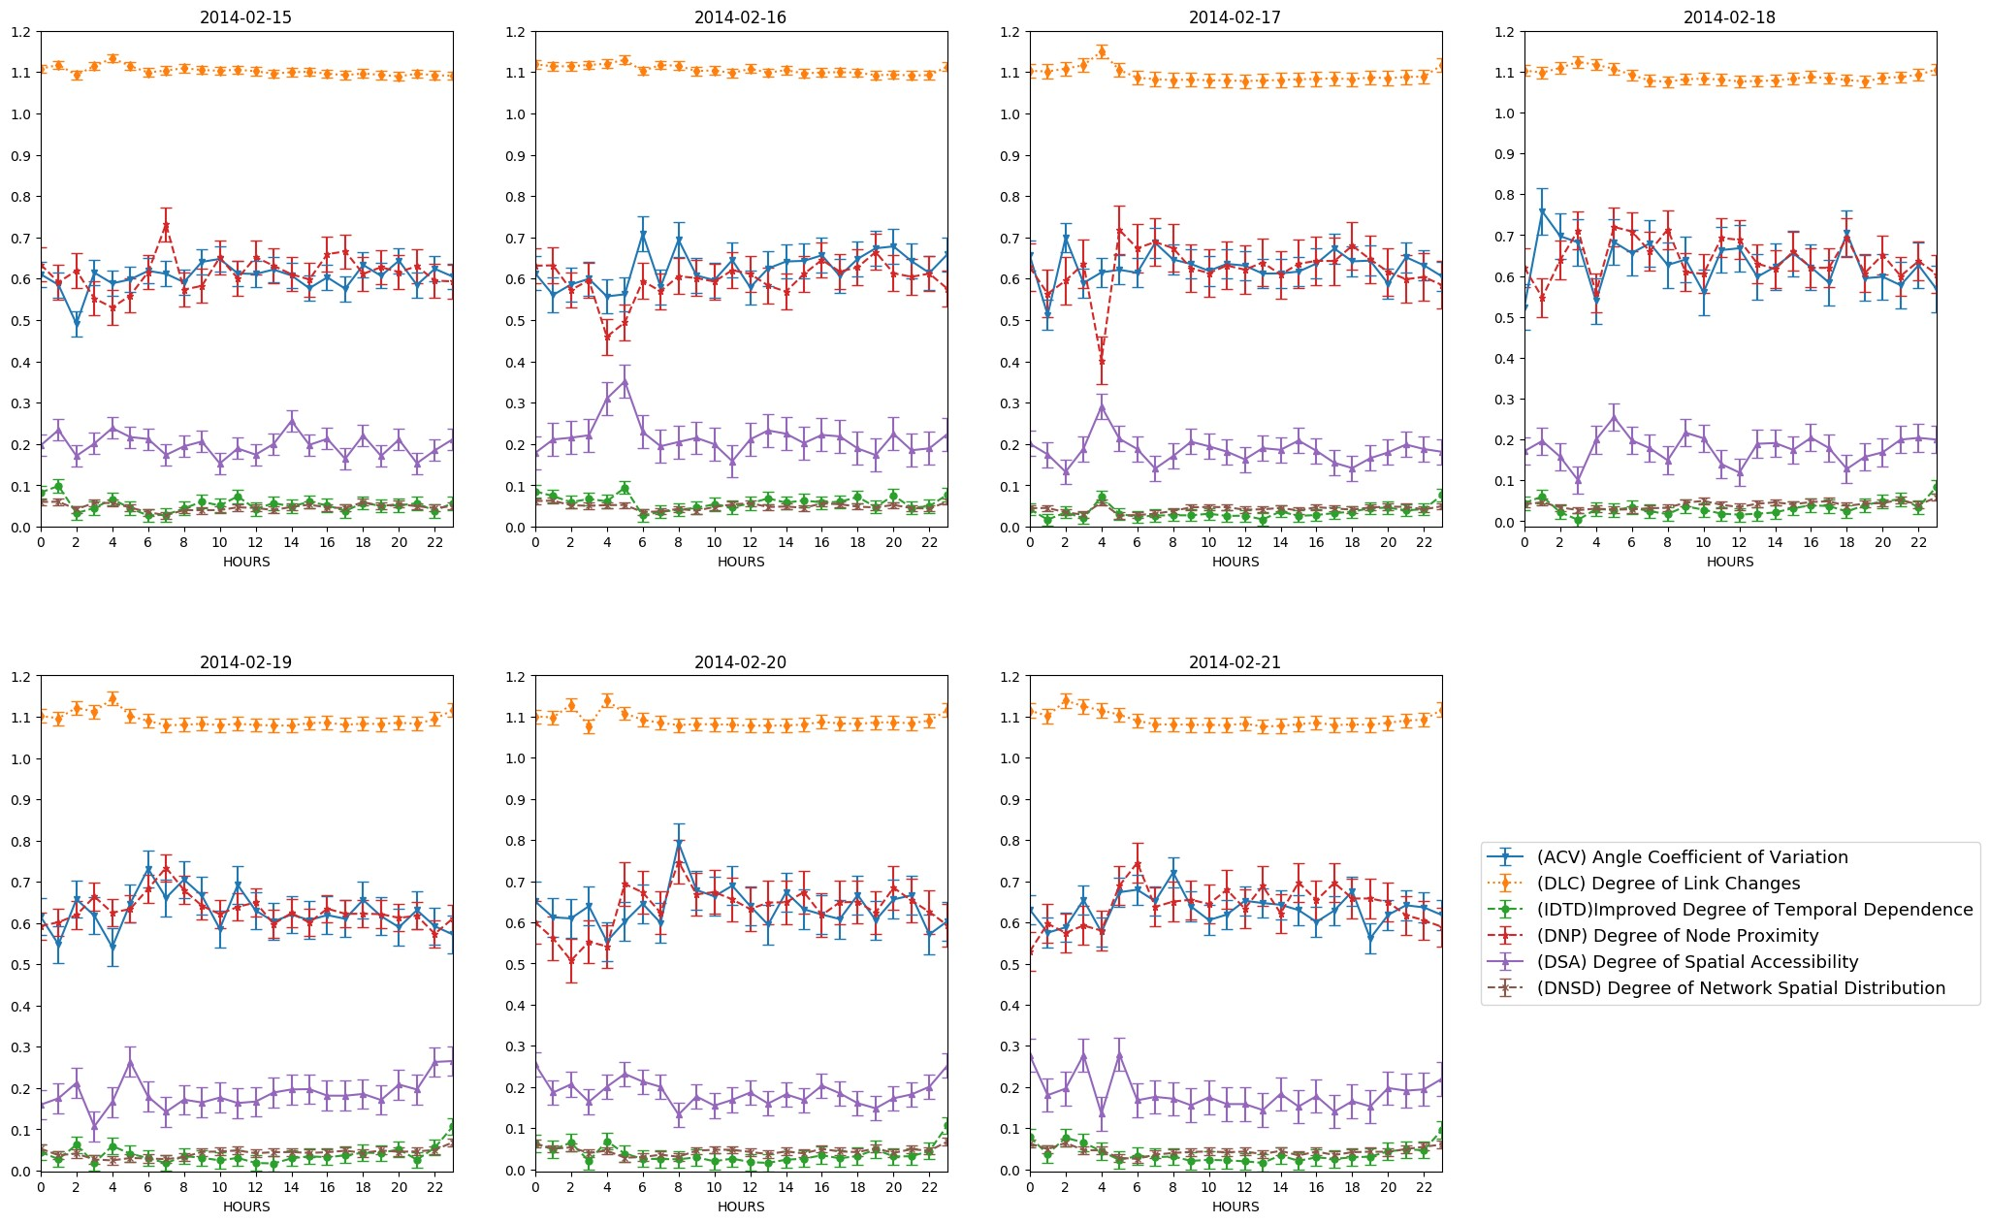

**Figure 4.** Third week results

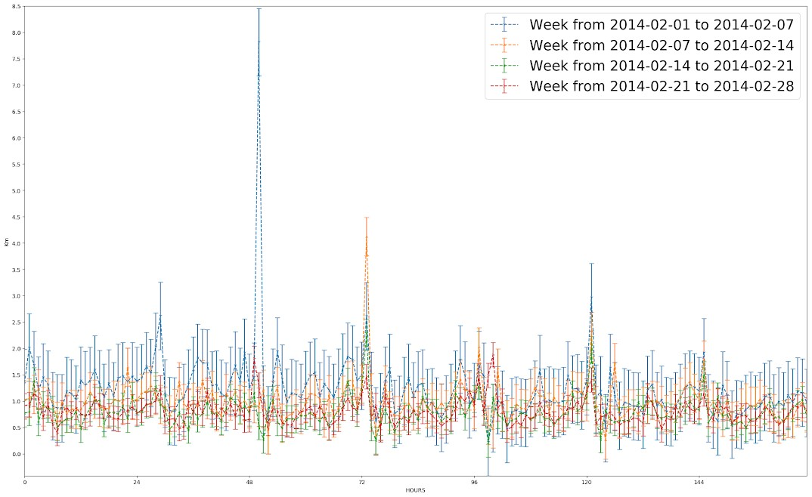

**Figure 5.** ATL results

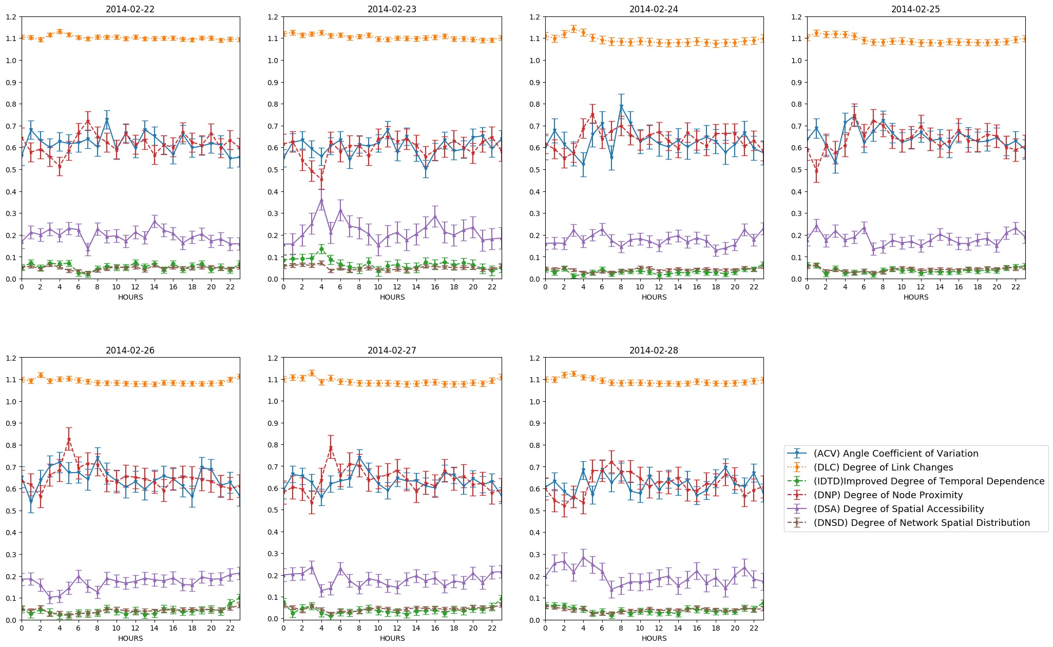

**Figure 6.** Fourth week results

seen as comprising a Vehicular Ad hoc NETwork (VANET). Their main objective was to better understand and characterize the interactions among the cabs. The analysis was based on statistical techniques, temporal graphs, and some metrics of complex networks. The main results point to the existence of some regularity (*e.g.*, presence of rush times) and common interests (*i.e.*, users sharing some destinations).

Silva *et al.* [36] pointed out that there are spatial and temporal gaps in some mobility data traces. They focused their analysis on taxi traces: the dataset from Rome, the one from San Francisco/CA, and an additional one from Shangai. The dataset from Rome was shown to present the smallest gaps among all three datasets. They proposed a cluster-based solution to fill the gaps (*i.e.*, to calibrate the datasets). Even though the resulting calibrated datasets are said to be publicly available, the paper presents no reference from where one could possibly obtain such data.

# 5. CONCLUSIONS

Even though we analysed just one dataset of mobility traces, results suggest that mobility metrics, originaly designed for synthetic models, can provide some useful details for real traces. For our particular scenario (*i.e.*, taxi cabs), we can summarize the main results as: i) most of the time, cabs are within range of communication of other cabs; ii) rides share some similarity, due to regular customers and/or particular points of interest in the city, resulting in rides with related lenghts; iii) even though cabs might have frequent communication contacts with other cabs, links are as quite prone to breakage as they are to get established; iv) in addition to mobility being geographicaly restricted, it also indicates a low uniformity, likely due to the fact that cabs usually concentrate in regions with more demand; and v) apart from having some micro patterns, it also shows an expected level of randomness in the whole process (*e.g.*, there are similarities among overlapping rides, but they remain independent among all other non overlapping rides).

When extending the analysis to synthetic mobility models, three somehow related mobility models (i.e., CMM, Column, and RPGM) were identified to better match the behavior depicted in the real traces. Even though such synthetic models are aimed at providing more realistic traces for the simulation of mobile ad hoc networks, the metrics may have some pontential for supporting the analysis of a greater variety of real mobility traces.

In order to advance the research following the proposed methodology, one could analyse the impact of varying the radio range. Given that it affects how and when cabs are able to reach each other, it is expected to affect some metrics, allowing new insights into the resulting scenarios. In addition to that, one can extend the analysis to other mobility traces and metrics, as they become more and more available.

# ACKNOWLEDGEMENTS

This work was partially supported by the Brazilian National Council for Scientific and Technological Development (CNPq) under grant 444610/2014-6.

**AUTHOR CONTRIBUTIONS**

Both authors have contributed equally to the work.

# REFERENCES

1. THEOLEYRE, F.; TOUT, R.; VALOIS, F. New metrics to evaluate mobility models properties. In: *2nd Int. Symp.*

*Wirel. Pervasive Comput.* San Juan, Porto Rico: IEEE, 2007. (ISWPC, ’7).

1. KIM, M.; KOTZ, D.; KIM, S. Extracting a mobility model from real user traces. In: DOMINGO-PASCUAL,

J. (Ed.). *Proceedings of IEEE Conference on Computer Communications*. Barcelona, Spain: IEEE, 2006. (INFOCOM, ’06).

1. MAEDA, K. et al. Getting urban pedestrian flow from simple observation: realisticmobility generation in wireless network simulation. In: *Proc. 8th ACM Int. Symp. on Modeling, Analysis and Simulation ofWireless and Mobile Systems*. Montreal, Quebec, Canada: ACM, 2005. (MSWiM,´

’05).

1. MUNJAL, A.; CAMP, T.; NAVIDI, W. Constructing

rigorous manet simulation scenarios with realistic mobility. In: *European Wireless Conference (EW)*. Lucca, Italy: IEEE, 2010. (EW, ’10).

1. RAY, S. *Realistic Mobility for MANET Simulation*.

Dissertac¸ao (Mestrado) — Department of Computer Science˜

- The University of British Columbia, Vancouver, Canada, 2003.

1. LIBERATORE, M.; SHENOY, P. *Umass trace repository*. 2009. Online, http://traces.cs.umass.edu.
2. KOTZ, D.; HENDERSON, T. Crawdad: A community resource for archiving wireless data at dartmouth. *IEEE Pervasive Comput.*, v. 4, n. 4, p. 12–14, 2005.
3. UNC/FORTH, M. C. G. at. *UNC/FORTH Archive of Wireless Traces, Models, and Tools*. 2006. Online, http://netserver.ics.forth.gr/datatraces.
4. BRACCIALE, L. et al. *CRAWDAD dataset roma/taxi (v. 2014-07-17)*. 2014. Downloaded from https://crawdad.org/roma/taxi/20140717.
5. HONG, X. et al. A group mobility model for ad hoc wireless networks. In: BOUKERCHE, A.; LIN, J. Y.-B. (Ed.). *Proc. 2nd ACM Int. Workshop on Modeling, analysis and simulationof wireless and mobile systems*. Seattle, United States: ACM, 1999. (MSWiM, ’99).
6. LIANG, B.; HAAS, Z. Predictive distance-based mobility management for pcs networks. In: DOSHI, B. (Ed.).

*Proc. 18th Int. Conf. on Computer Communications*. New york, USA: IEEE, 1999. (INFOCOM, ’99).

1. BAI, F.; SADAGOPAN, N.; HELMY, A. IMPORTANT: A framework to systematically analyze the impact ofmobility on performance of routing protocols for adhoc networks. In: SASAKI, G. et al. (Ed.). *Proc. 22nd IEEE Int. Conf. on Computer Communications*. San Franciso, USA: IEEE, 2003. (INFOCOM ’03, ’03).
2. MUSOLESI, M.; MASCOLO, C. Designing mobility models based on social network theory. *Mob. Comput. Commun. Rev.*, v. 11, n. 3, p. 59–70, 2007.
3. LEE, K. et al. SLAW: A new mobility model for human walks. In: *28th IEEE International Conference on Computer Communications*. Rio de Janeiro, Brazil: IEEE, 2009. (INFOCOM, ’09).
4. MUNJAL, A.; CAMP, T.; NAVIDI, W. SMOOTH: a simple way to model human mobility. In: HELMY, A.; LANDFELDT, B.; BONONI, L. (Ed.). *Proceedings of the*

*14th International Symposium on Modeling Analysisand Simulation of Wireless and Mobile Systems*. Miami, USA: ACM, 2011. (MSWiM, ’11).

1. ROY, R. R. *Handbook of Mobile Ad Hoc Networks for Mobility Models*. 1. ed. New York City, USA: Springer, 2011. v. 1.
2. HARRI, J.; FILALI, F.; BONNET, C. Mobility models for vehicular ad hoc networks: a survey and taxonomy. *IEEE Commun. Surv. Tutor.*, v. 11, n. 4, p. 19–41, 2009.
3. OZTA, B.; KURT, T.; ANARIM, E. A survey of social based mobility models for ad hoc networks. In: *2011 2nd International Conference on Wireless Communication,*

*Vehicular Technology, Information Theory and Aerospace Electronic Systems Technology (Wireless VITAE)*. Chennai, India: IEEE, 2011. ’11.

1. CAVALCANTI, E. R.; SPOHN, M. A. Degree of

node proximity: a spatial mobility metric for manets. In: *Proceedings of the 9th ACM international symposium on Mobility managementand wireless access*. New York, USA: ACM, 2011. (MobiWac, ’11).

1. CAVALCANTI, E. R.; SPOHN, M. A. Predicting mobility metrics through regression analysis for random.

In: ACM. *Proceedings of the 15th IEEE Symposium on Computers and Communications(ISCC)*. Riccione, Italy, 2010. (ISSCC, ’10).

1. CAVALCANTI, E. R.; SPOHN, M. A. On the applicability of mobility metrics for user movement patternrecognition in manets. In: *Proceedings of the 11th ACM International Symposium on Mobility Managementand Wireless Access*. New York, USA: ACM, 2013. (MSWiM,

’13).

1. CAVALCANTI, E. R.; SPOHN, M. A. On improving temporal and spatial mobility metrics for wireless adhoc networks. *Inform. Sciences*, v. 188, n. 1, p. 182–197, 2012. [23] CAVALCANTI, E. R.; SPOHN, M. A. On realistic

evaluation of recent spatial and temporal mobility metricsfor mobile ad hoc networks. In: *Proceedings of the 10th ACM International Symposium on Mobility Managementand Wireless Access*. Paphos, Cyprus: ACM, 2012. (MobiWac,

’12).

1. KURKOWSKI, S. *Credible Mobile Ad Hoc Network*

*Simulation-Based Studies*. Tese (Doutorado) — Colorado School of Mines, Golden, USA, 2006.

1. AMICI, R. et al. Performance assessment of an epidemic protocol in vanet using real traces. *Procedia Comput. Sci.*, v. 40, p. 92 – 99, 2014.
2. CAVALCANTI, E. R. *TraceAnalyzer 2.5*. 2013. Online, https://sites.google.com/site/elmano/code.
3. BAI, F.; SADAGOPAN, N.; HELMY, A. *User Manual for IMPORTANT Mobility Tool Generators in ns-2 Simulator*.

1. ed. Los Angeles, USA, 2004.

1. MCCANNE, S. et al. *The Network Simulator NS-2*. 1997. Online.
2. ASCHENBRUCK, N. et al. *BonnMotion - a mobility scenario generation and analysis tool*.

http://net.cs.uni-bonn.de/wg/cs/applications/bonnmotion, 2013.

1. CAVALCANTI, E. R.; SPOHN, M. A. On the

applicability of mobility metrics for user movement pattern recognition in manets. In: NIKOLETSEAS, S.; RUM´ıN Angel C. (Ed.).´ *Proceedings of the 11th ACM International Symposium on Mobility Management and Wireless Access*. New York, NY, USA: ACM, 2013. (MobiWac, ’13).

1. SaNCHEZ, M.; MANZONI, P. Anejos: A java based´ simulator for ad hoc networks. *Future Gener. Comput. Syst.*, v. 17, n. 5, p. 573–583, 2001.
2. HONG, X. et al. A group mobility model for ad hoc wireless networks. In: BOUKERCHE, A.; LIN, J. Y.-B. (Ed.).

*Proceedings of the 2Nd ACM International Workshop on*

*Modeling, Analysis and Simulation of Wireless and Mobile Systems*. New York, NY, USA: ACM, 1999. (MSWiM, ’99).

1. MUSOLESI, M.; MASCOLO, C. Designing mobility models based on social network theory. *ACM SIGMOBILE Mob. Comput. Commun. Rev.*, v. 11, n. 3, p. 59–70, 2007.
2. HOQUE, M. A.; HONG, X.; DIXON, B. Analysis of

mobility patterns for urban taxi cabs. In: *2012 International Conference on Computing, Networking and Communications (ICNC)*. Maui, USA: IEEE, 2012. (ICNC, ’12).

1. CUNHA, F. D. et al. Understanding interactions in vehicular networks through taxi mobility. In: *Proceedings of the 12th ACM Symposium on Performance Evaluation of Wireless Ad Hoc, Sensor, &#38; Ubiquitous Networks*. New York, NY, USA: ACM, 2015. (PE-WASUN ’15, ’15).
2. SILVA, F. A. et al. Filling the gaps of vehicular mobility traces. In: *MSWiM*. Cancun, Mexico: ACM, 2015. (MSWiM,

’15).

1. Available at https://doi.org/10.5281/zenodo.1217602
2. Available at https://doi.org/10.5281/zenodo.1217611